Project Design Phase-II
Technology Stack (Architecture & Stack)

Date | 28 September 2026
Team ID | 6ab64d1802319e850fcd4e9e
Project Name | AI WeatherWise API
Maximum Marks | 4 Marks

Technical Architecture:
The Deliverable shall include the architectural diagram as below and the information as per the table1 & table 2
AI WeatherWise API — Technical Architecture
Project architecture based on the implemented Node.js/Express backend, MongoDB/Mongoose data layer, OpenWeatherMap and Google Gemini integrations.

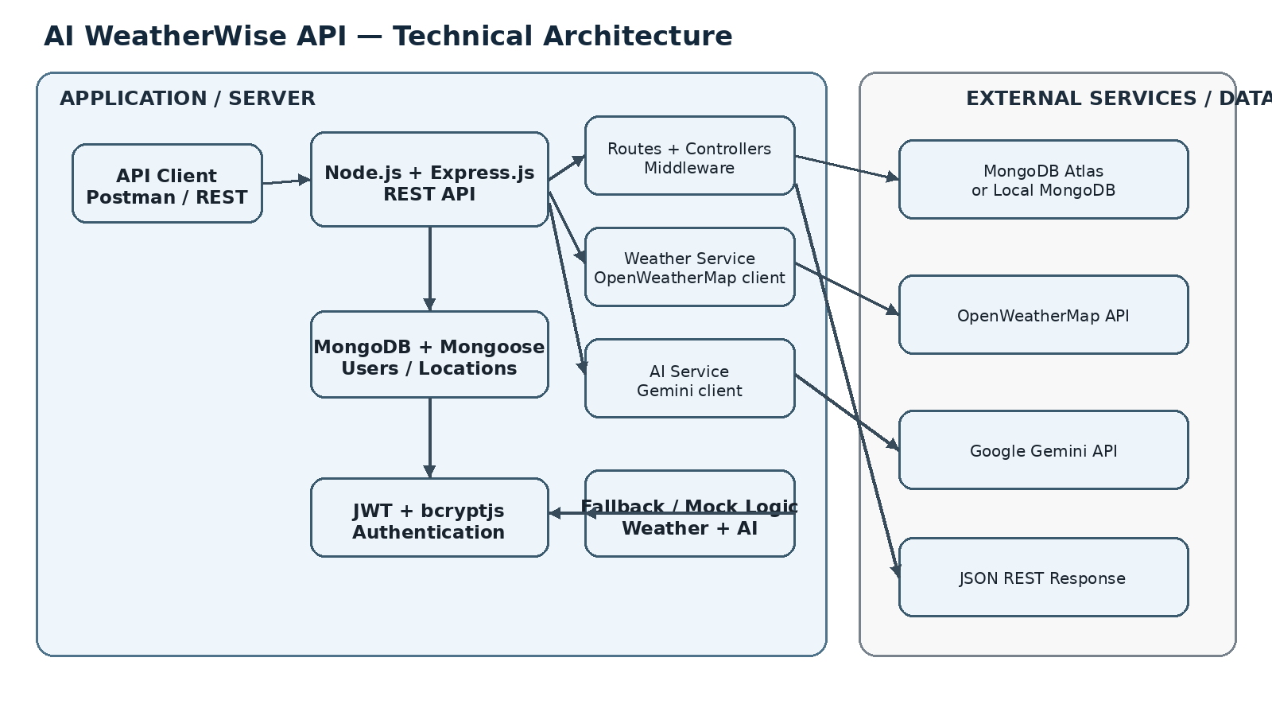

Table-1 : Components & Technologies:
S.No | Component | Description | Technology
1 | User Interface | API client used to send REST requests; no separate web/mobile UI is implemented in this backend project. | Postman / REST API
2 | Application Logic-1 | REST routing, controllers and middleware for authentication and resource handling. | Node.js, Express.js
3 | Application Logic-2 | Current-weather retrieval and weather-data processing with fallback logic. | weatherService.js, OpenWeatherMap API
4 | Application Logic-3 | AI weather summary and recommendation generation with fallback logic. | aiService.js, Google Gemini API
5 | Database | Stores user accounts and favorite locations through Mongoose schemas. | MongoDB, Mongoose
6 | Cloud Database | Cloud database option supported by the project. | MongoDB Atlas
7 | File Storage | No application file-storage component is required by the implemented backend. | Not applicable
8 | External API-1 | Retrieves current temperature, humidity, wind speed and weather condition. | OpenWeatherMap API
9 | External API-2 | Generates context-aware weather summaries and recommendations. | Google Gemini API
10 | Machine Learning Model | Generative AI model used for weather summaries and recommendations; no custom ML model is trained. | Google Gemini
11 | Infrastructure (Server / Cloud) | Node.js server runs the Express application; project supports local execution and MongoDB Atlas/local MongoDB. | Node.js / Express.js; Local or MongoDB Atlas

Table-2: Application Characteristics:
S.No | Characteristics | Description | Technology
1 | Open-Source Frameworks | Backend uses Node.js, Express.js and Mongoose ODM. | Node.js, Express.js, Mongoose
2 | Security Implementations | Passwords are hashed with bcryptjs and protected routes use JWT token authorization. | bcryptjs, jsonwebtoken
3 | Scalable Architecture | Separated routes, controllers, services, models and middleware support modular extension. | Express.js, Mongoose, MongoDB
4 | Availability | Fallback/mock logic keeps weather and AI-related endpoints testable when external API keys are unavailable. | Local deterministic fallback logic
5 | Performance | Lightweight REST structure separates external service calls and database access; no specific performance benchmark is defined. | Node.js, Express.js, Mongoose

References:
https://c4model.com/
https://developer.ibm.com/patterns/online-order-processing-system-during-pandemic/
https://www.ibm.com/cloud/architecture
https://aws.amazon.com/architecture
https://medium.com/the-internal-startup/how-to-draw-useful-technical-architecture-diagrams-2d20c9fda90d

